**AICTE Activity Point Programme Report**

Submitted in Partial Fulfilment for the Award of Degree of

Bachelor of Engineering

in

Computer Science and Engineering

Submitted by

Srusti S

1NT21CS177

**Under the guidance of**

Dr Janardhana D R

Assistant Professor

Dept of Computer Science and Engineering,

Nitte Meenakshi Institute of Technology



**2024-2025**

**AICTE Activity Point Programme CERTIFICATE**

This is to certify that the AICTE Activity Point Programme has been successfully carried out by Srusti S bearing USN 1NT21CS177, Bonafide student of **Nitte Meenakshi Institute of Technology** in partial fulfilment of the requirements for the award of degree of **Computer Science and Engineering** of **Visvesvaraya Technological University**, **Belagavi** during **20204-2025**. It is certified that all corrections/suggestions indicated for Internal Assessment have been incorporated in the report. The AICTE Activity Point Programme report has been approved as it satisfies the academic requirements in respect of AICTE Activity Point Programme for the said degree.

…………… …………… …….……

Signature Signature Signature

Dr Janardhana D R Dr S Meenakshi Sundaram Dr. Karunakara Rai/ Dr. Deepika K M

Assistant Professor Professor and Head AICTE points faculty coordinator

Dept of CSE, NMIT Dept of CSE, NMIT NMIT

**CERTIFICATE**

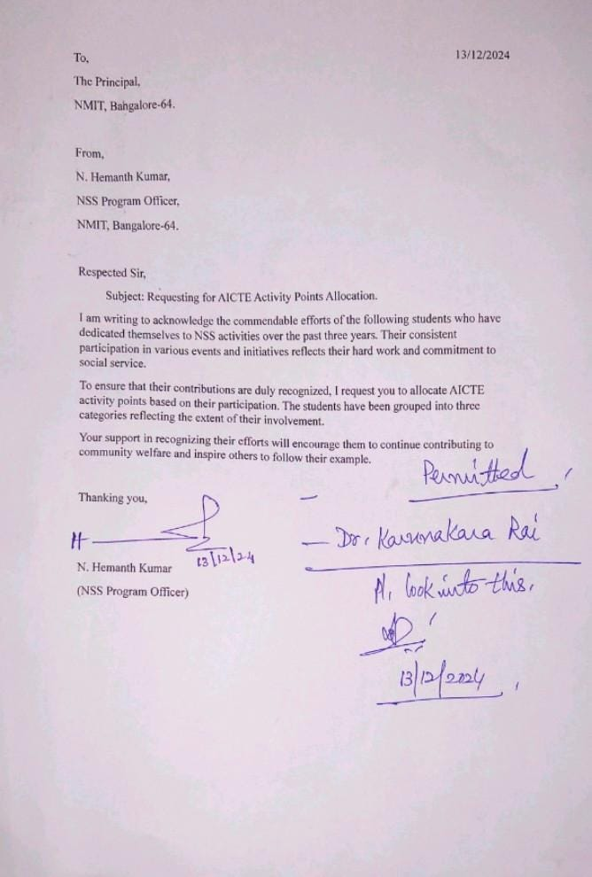

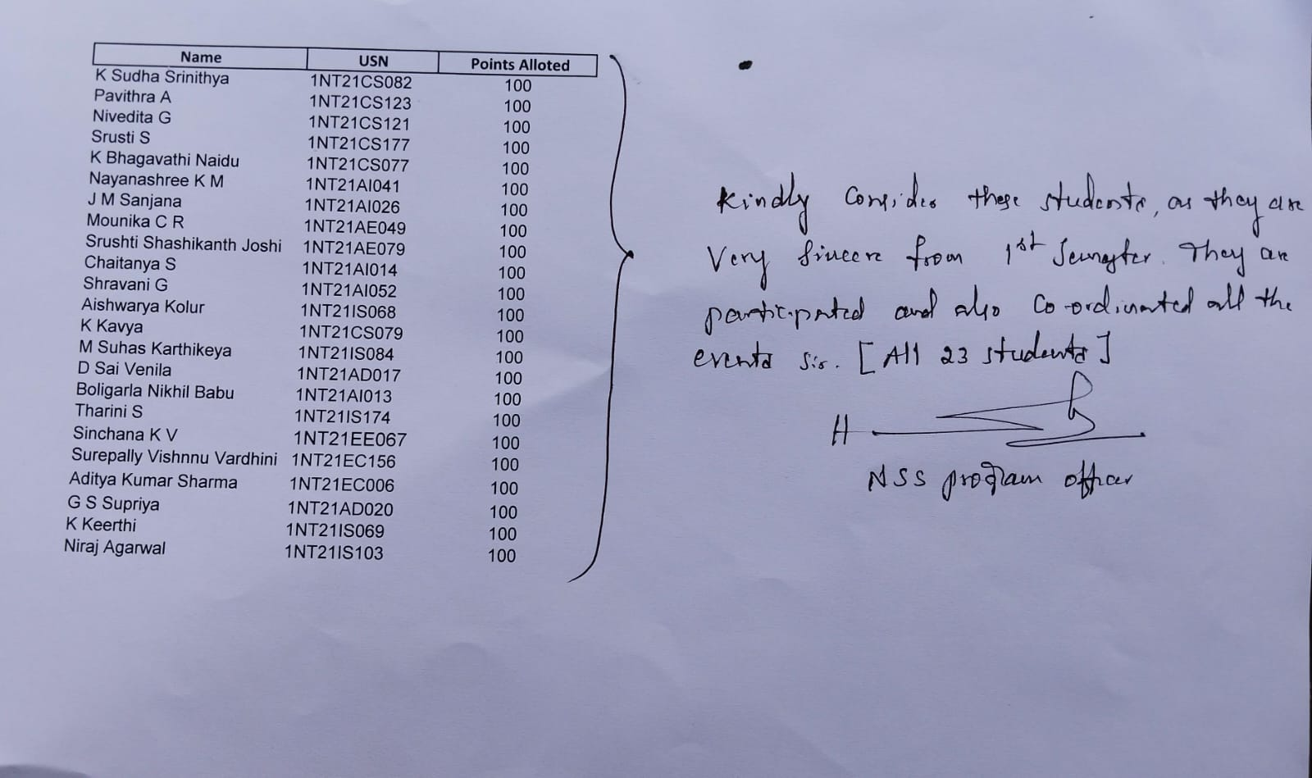

**DECLARATION**

I, Srusti S bearing the USN:1NT21CS177, student of Bachelor of Engineering, **Computer Science and Engineering, Nitte Meenakshi Institute of Technology, Bengaluru,** hereby declare that the **AICTE Activity Point Programme** work has been carried out by me under the supervision and guidance of **Dr Janardhana D R** submitted by me as a partial fulfilment for the award of Bachelor of Engineering degree in **Computer Science and Engineering,**  from **Visvesvaraya Technological University, Belagavi** during **2024-2025.**

I hereby declared that the AICTE activity point work has been carried out at NSS.

**Signature**

Name: Srusti S

USN: 1NT21CS177

**ACKNOWLEDGEMENT**

I extend my heartfelt gratitude to **Dr. H C Nagaraj**, Principal of **Nitte Meenakshi Institute of Technology;** **Mr Hemanth Kumar N,** Professor at **Nitte Meenakshi Institute of Technology;** and **Mr Karunakar Rai**, AICTE Activity Points Coordinator at **Nitte Meenakshi Institute of Technology** for their unwavering support and provision of essential resources for the successful execution of this program.

I am also deeply thankful to **NSS (National Service Scheme) and team** for their invaluable support in offering meaningful volunteering opportunities and resources.

Lastly, I would like to express my sincere appreciation and respect to my parents, the teaching and non-teaching staff of the Department, and all my friends who have supported me, directly or indirectly, throughout my AICTE Activity Point Programme journey.

**Student Name: SRUSTI S**

**USN number: 1NT21CS177**

**ACTIVITY SUMMARY**

|  |  |  |  |  |
| --- | --- | --- | --- | --- |
| **Si. No.** | **Activity Heads** | **From date**  **–**  **To date** | **Number of Days** | **Total Number of Hours** |
| **1.** | **DAILY YOGA FOR HEALTH AND PEACE** | 27th July to 28th August 2023 | **28** | **56** |
| **2.** | **TEACHER’S DAY CELEBRATION** | 5th September 2023 | **1** | **6** |
| **3.** | **GURUVANDANA & OUTREACH ACTIVITY** | 8th September 2023 | **1** | **8** |
| **4.** | **BLOOD DONATION CAMP** | 15th December 2023 | **1** | **8** |
| **5.** | **SWACHH BHARAT DRIVE – NANDI HILLS** | 23rd December 2023 | **1** | **8** |

|  |  |  |  |  |  |  |  |  |
| --- | --- | --- | --- | --- | --- | --- | --- | --- |
|  | **Very Good**  **(8-10)** | **Good**  **(6-7)** | **Average**  **(5)** | **Activity-1** | **Activity-2** | **Activity-3** | **Activity-4** | **Activity-5** |
| **Need Analysis** | Thoroughly identified and understood specific community needs. | Identified and addressed most key community needs | Identified some needs but lacked comprehensive analysis. |  |  |  |  |  |
| **Implementation** | Executed effectively with exceptional efficiency and impact. | Implemented well with minor improvements possible. | Implemented partially with noticeable gaps in execution. |  |  |  |  |  |
| **Community Involvement** | Engaged community fully with outstanding collaboration efforts. | Involved community well with some collaboration gaps. | Engaged community minimally with limited collaboration efforts. |  |  |  |  |  |
| **Impact Measurement** | Thoroughly measured impact with clear, measurable outcomes. | Measured impact with clear outcomes, though incomplete. | Measured impact partially with limited data or analysis. |  |  |  |  |  |
| **Total** | | | |  |  |  |  |  |
| **Grand Total** | | | | | | | |  |

**Rubrics for Activity Points**

**ABSTRACT**

A series of impactful community service and sustainability-focused activities were carried out as part of the AICTE Activity Point Programme. These initiatives emphasized environmental responsibility, public health awareness, and social inclusion. Activities included awareness sessions on organic kitchen gardening, composting, and chemical-free food practices, encouraging participants to adopt eco-friendly and healthier lifestyles.

Volunteers actively engaged in Shramadan drives at temples and NGOs, contributing to cleanliness, hygiene, and public space restoration. At Sumangali Seva Ashrama, students participated in organizing educational resources, conducting games for children, and preparing awareness material on pressing social issues such as women’s empowerment, waste management, and the impact of COVID-19 on vulnerable groups.

Visits to primary health centers provided insights into community healthcare systems and maternal health services. Plantation drives and environmental awareness sessions further deepened the commitment to sustainable living.

Throughout the programme, students demonstrated teamwork, empathy, and cultural sensitivity. Despite challenges such as time constraints and communication gaps, effective planning and group coordination ensured successful outcomes. Feedback from beneficiaries affirmed the positive impact of these activities on both the community and participants.

These experiences fostered a strong sense of civic duty and personal growth, reinforcing the value of ethical engagement, continuous learning, and inclusive community development.

**CONTENTS**

1. **CHAPTER 1**

INTRODUCTION

1. **CHAPTER 2**

ACTIVITY HEAD- 1 DAILY YOGA FOR HEALTH AND PEACE

2.1. Overview

2.2. Use of Technology (if any)

2.3. Sustainable Development best practices

ACTIVITY HEAD- 2 TEACHER’S DAY CELEBRATION

2.1. Overview

2.2. Use of Technology (if any)

2.3. Sustainable Development best practices

ACTIVITY HEAD- 3 GURUVANDANA & OUTREACH ACTIVITY

2.1. Overview

2.2. Use of Technology (if any)

2.3. Sustainable Development best practices

ACTIVITY HEAD- 4 BLOOD DONATION CAMP

2.1. Overview

2.2. Use of Technology (if any)

2.3. Sustainable Development best practices

ACTIVITY HEAD- 5 SWACHH BHARAT DRIVE – NANDI HILLS

2.1. Overview

2.2. Use of Technology (if any)

2.3. Sustainable Development best practices

**3. CHAPTER 3**

OVERALL LEARNINGS

3.1. Innovative approaches taken

3.2. Research done

3.3. Knowledge and Understanding gained

3.4. Professional Values and best practices incorporated

3.5. Areas for further development

3.6. Challenges and solutions

3.7. Feedback and continuous improvement

1. **CHAPTER 4**

DOCUMENTATION OF ACTIVITIES

**5. CHAPTER 5**

CONCLUSION

**CHAPTER 1**

**INTRODUCTION**

A wide range of community service and awareness activities were undertaken to promote sustainable living, social responsibility, and holistic development under the AICTE Activity Point Programme. The activities spanned environmental initiatives, public health awareness, and social empowerment projects. These included Shramadan (voluntary labor) at public and religious places, cleanliness drives at temples and NGOs, and educational outreach efforts at Sumangali Seva Ashrama. Participants were also involved in organic kitchen gardening workshops, write-ups on social issues such as women’s empowerment and COVID-19 challenges, visits to healthcare centers, and the organization of games and library resources for children. Emphasis was placed on sustainable practices like waste segregation, composting, and eco-conscious living. These activities collectively fostered a spirit of service, environmental stewardship, and community engagement among student volunteers.

**CHAPTER 2**

**ACTIVITY HEAD 1: DAILY YOGA FOR HEALTH AND PEACE**

**2.1. Overview:**  
From 27th July to 28th August 2023, the NSS unit of NMIT conducted a daily yoga session for students to promote physical and mental well-being. The program was inaugurated by Sri Sampath Kumar Guruji from Swami Vivekananda Yoga Kendra. The sessions focused on yoga postures, breathing exercises, and mental relaxation techniques.

**2.2. Use of Technology (if any):**  
No advanced technology was used; the sessions were conducted in person.

**2.3. Sustainable Development Best Practices:**

* Encouraged mental wellness and physical fitness.
* Promoted stress-free, balanced lifestyles among students.
* Fostered regular wellness habits through daily engagement.

**ACTIVITY HEAD 2: TEACHER’S DAY CELEBRATION**

**2.1. Overview:**  
On 5th September 2023, NSS volunteers celebrated Teacher’s Day at government schools in Gantiganahalli, Harohalli, and Nagenahalli. Students explained the importance of the day to schoolchildren and distributed sweets to teachers and students, reinforcing respect for educators.

**2.2. Use of Technology (if any):**  
No technology was involved.

**2.3. Sustainable Development Best Practices:**

* Promoted value-based education.
* Strengthened community-school relations.
* Fostered student engagement in rural education.

**ACTIVITY HEAD 3:** **GURUVANDANA & OUTREACH ACTIVITY**

**2.1. Overview:**  
Held on 8th September 2023 at Sri Vivekananda Ramakrishna Ashrama, Malluru, this activity involved spiritual interaction with Swamiji and visits to the blind school in Shidlaghatta and Sir M. Vishveshwarayya’s Mahasamadhi. Students engaged with blind children and participated in cultural exchanges.

**2.2. Use of Technology (if any):**  
No use of technology.

**2.3. Sustainable Development Best Practices:**

* Promoted inclusion and empathy.
* Strengthened moral and cultural education.
* Encouraged social interaction with differently-abled communities.
* Improved public hygiene through direct action.

**ACTIVITY HEAD 4: BLOOD DONATION CAMP**

**2.1. Overview:**  
On 15th December 2023, a blood donation camp was organized in association with Rastrothana and Vivekananda Blood Banks. Over 150 units of blood were collected, with participation from students and faculty.

**2.2. Use of Technology (if any):**  
Basic blood bank equipment was used for blood collection and storage.

**2.3. Sustainable Development Best Practices:**

* Promoted health and emergency preparedness.
* Encouraged voluntary healthcare support.
* Built awareness about regular blood donation.

**ACTIVITY HEAD 5:** **SWACHH BHARAT DRIVE – NANDI HILLS**

**2.1. Overview:**  
On 23rd December 2023, students conducted a cleanliness drive at Nandi Hills to maintain the tourist site. Litter and plastic waste were removed to preserve the environment.

**2.2. Use of Technology (if any):**  
No technology used.

**2.3. Sustainable Development Best Practices:**

* Promoted eco-tourism and responsible travel.
* Reinforced environmental conservation.
* Advocated for waste segregation and reduction.

**CHAPTER 3  
OVERALL LEARNINGS**

**3.1. Innovative Approaches Taken**

During the various NSS activities conducted from August 2023 to May 2024, several creative and impactful approaches were adopted to ensure deeper engagement and better outcomes:

* Daily Yoga sessions were implemented not just as a fitness initiative, but as a holistic mental wellness practice encouraging mindfulness and stress management.
* Walkathons for awareness (on Swachh Bharat and anti-plastic use) creatively engaged local communities, using visual aids, placards, and direct conversations to spread environmental and civic messages.
* Distribution of eco-friendly paper covers during the special camp promoted sustainable alternatives to plastic in local markets.
* Interactive school-based programs like Teacher’s Day Celebrations and Guruvandana events used cultural storytelling and student-led sessions to communicate values of gratitude and respect.
* Trekking with environmental cleanup combined adventure with awareness, turning physical activity into environmental activism.

**3.2. Research Done**

Prior to these activities, volunteers were encouraged to undertake relevant background research to make their contributions more meaningful:

* Studied the Swachh Bharat Mission and its community-level impact to design targeted cleaning drives.
* Explored plastic pollution data and alternatives, which informed awareness messages during the walkathon and paper bag distribution.
* Reviewed the importance of blood donation, including safety practices, to assist in organizing and promoting the Blood Donation Camp.
* Learned about yoga’s scientific benefits, supporting the rationale for the month-long yoga sessions.
* Researched inclusive education methods for blind children prior to the outreach visit at Asha Kirana School.

**3.3. Knowledge and Understanding Gained**

Students gained multi-dimensional learning outcomes from these activities:

* Developed a strong understanding of community engagement and the diverse needs of people in rural and urban settings.
* Understood the impact of awareness campaigns in influencing behavior, especially regarding cleanliness and voting participation.
* Gained insight into eco-friendly practices like waste segregation, organic living, and plastic-free alternatives.
* Experienced firsthand the challenges faced by the underprivileged, enhancing emotional intelligence and empathy.

**3.4. Professional Values and Best Practices Incorporated**

Throughout the program, participants adhered to and cultivated key professional and ethical values:

* Teamwork and collaboration during cleaning drives and event coordination.
* Leadership and responsibility, as students independently led activities and guided peers.
* Cultural sensitivity and respectful communication during visits to schools, temples, ashrams, and health camps.
* Commitment to public service, shown through voluntary participation and consistency in daily yoga and long-duration events.

**3.5. Areas for Further Development**

While the program was successful, certain aspects could be improved for future NSS initiatives:

* More structured orientation sessions for each event to better prepare volunteers.
* Improved community feedback mechanisms, such as surveys or group discussions, post-activity.
* Greater involvement of local authorities or experts in awareness events for better reach and credibility.
* Development of follow-up plans for ongoing impact after the completion of events.

**3.6. Challenges and Solutions**

Several challenges were encountered during the course of the NSS program:

* Logistical difficulties during long-distance activities like Nandi Hills and Kaiwara camp were handled through pre-planned travel and time management.
* Engaging local communities, especially in rural areas, was initially difficult. This was addressed by using approachable language, visual materials, and relatable messaging.
* Weather-related issues during outdoor events were managed by having contingency indoor plans.
* Maintaining volunteer participation across multiple events was ensured through strong coordination, communication, and peer encouragement.

**3.7. Feedback and Continuous Improvement**

Feedback from participants and the communities was highly encouraging:

* Students expressed personal growth in confidence, leadership, and empathy.
* Community members appreciated the cleanliness drives and awareness campaigns, especially in schools, temples, and health centers.
* Organizers noted high levels of enthusiasm during yoga, blood donation, and village activities.

Future Plans for Improvement:

* Include reflection sessions after each event to document learning.
* Conduct workshops on soft skills and community engagement.
* Establish sustainable partnerships with local organizations for ongoing service projects.
* Create a digital record of events for transparency, review, and motivation for future batches.

**CHAPTER 4**

**DOCUMENTATION OF ACTIVITIES**

